# VISVESVARAYA TECHNOLOGICAL UNIVERSITY

"Jnana Sangama", Belagavi - 590018



A Report on

**NAICTE Activity**



**NON CREDIT MANDATORY COURSE**

Submitted in partial fulfillment of the requirement for the award of the degree of

**Bachelor of Engineering in**

**Computer Science and Engineering**

By

**ANISH KUMAR 1AY21CS028**

Under the guidance of

**Mrs. VARALAKSHMI B D M E**

**Assistant Professor**

#### Department of Computer Science and Engineering



**DEPARTMENT OF COMPUTER SCIENCE AND ENGINEERING**

# ACHARYA INSTITUTE OF TECHNOLOGY

(Affiliated to Visvesvaraya Technological University, Belagavi)

#### 2022-2023

**ACHARYA INSTITUTE OF TECHNOLOGY**



Acharya Dr. Sarvepalli Radhakrishnan Road, Soladevanahalli, Bengaluru – 560107 (Affiliated to Visvesvaraya Technological University, Belagavi)

**DEPARTMENT OF COMPUTER SCIENCE AND ENGINEERING**

**CERTIFICATE**

Certified that the report entitled **AICTE Activity –** Cleaning the land (Durgamba Temple on Hessaraghatta Lake Bund) from waste is an activity carried out by **ANISH KUMAR 1AY21CS028** in partial fulfillment for the award of degree of **Bachelor of Engineering in Computer Science and Engineering of Visvesvaraya Technological University**, **Belagavi** during **3rd semester** in the year **2022-2023.** It is certified that all corrections/suggestions indicated for internal assessments have been incorporated in the report deposited in the departmental library. The activity report **[21NS83]** has been approved as it satisfies the academic requirements in respect of project prescribed for the **Bachelor of Engineering Degree**.

|  |  |  |
| --- | --- | --- |
| Signature of NSS Coordinator | Signature of HOD | Signature of Principal |
| **Mrs Varalakshmi B D** | **Dr. Ajith Padyana** | **Dr. Rajath Hegde. M.M** |
| **Assistant Professor** | **HOD** | **Principal** |
| **External**  **Name of Examiner** | **AICTE Officer, AIT** | **Signature with Date** |



I student of 3rd semester, B.E Computer Science and Engineering, Acharya Institute of Technology, Bangalore, hereby declare that the activity report entitled **“AICTE Activity -** Cleaning the land (Durgamba Temple on Hessaraghatta Lake Bund) from waste**”** is an authentic activity report of our own work carried out under the supervision and guidance of Mrs. Varalakshmi B D, Assistant Professor and NSS CSE Department Coordinator, Department of Computer Science and Engineering, Acharya Institute of Technology, Bangalore. Ihave not submitted the matter embodied to any otherUniversity or Institution for the award of any other degree.

Date: 02/09/2023 Place: Bengaluru

**ANISH KUMAR 1AY21CS028**

We express our gratitude to our institution and management for providing us with good infrastructure, laboratory, facilities and inspiring staff, and whose gratitude was of immense help in completion of this report successfully.

We are deeply indebted to **Dr. Rajath Hegde. M. M** Principal, Acharya Institute of Technology, Bengaluru, who has been a constant source of enthusiastic inspiration to steer us forward.

We heartily thank **Dr. Ajith Padyana**, Head of the Department, Department of Mechanical Engineering, Acharya Institute of Technology, Bengaluru, for his valuable supportand for rendering us resources for this activity.

We specially thank **Mrs. Varalakshmi B D,** Assistant Professor and NSS CSE Department Coordinator, Department of Computer Science and Engineering, Acharya Institute of Technology, Bangalore who guided us with valuable suggestions in completing this project atevery stage.

We would like to express our sincere thanks and heartfelt gratitude to Computer Science and Engineering staff members, our beloved Parents, Respected Professors, Classmates, Friends and non-teaching staff for their indispensable help at all times.

Last but not the least our respectful thanks to the Almighty.

**ANISH KUMAR 1AY21CS028**

|  |  |  |
| --- | --- | --- |
| **Sl.no** | **Content** | **Page no** |
| **1** | **Abstract** | **7** |
| **2** | **Introduction** | **7-9** |
| **3** | **Temple Overview** | **9-12** |
| **4** | **Architectural Elegance** | **13** |
| **5** | **Cultural Significance** | **14** |
| **6** | **The Journey to Serenity** | **14** |
| **7** | **The Temple Visit Experience** | **15-16** |
| **8** | **Community and Devotees** | **16** |
| **9** | **Challenges and Preservation** | **16-18** |
| **10** | **Conclusion** | **18-19** |
| **11** | **References** | **19** |

|  |  |  |
| --- | --- | --- |
| **Sl.no** | **Name** | **Page no** |
| 2.1 | Visit Photo | 7 |
| 3.1 | Temple Overview | 9 |
| 3.2 | Cultural Relevance | 12 |
| 4.1 | Aesthetic Features | 13 |
| 6.1 | Spiritual Atmosphere | 15 |

## Abstract

This report documents an in-depth exploration of the Durgamba Temple situated on the

Hessaraghatta Lake bund, offering a comprehensive understanding of the temple's historical and cultural significance, its architectural and aesthetic features, the journey to the temple, the spiritual experience, and its role as a cherished cultural landmark in the region.

This comprehensive report offers an extensive exploration of the Durgamba Temple, situated on the picturesque Hessaraghatta Lake Bund, in the vicinity of Bangalore, India. The report delves into the temple's historical roots, architectural aesthetics, cultural importance, and the spiritual experiences it offers to visitors. Additionally, it examines the role of the temple in the local community and addresses preservation and conservation challenges.

## Introduction

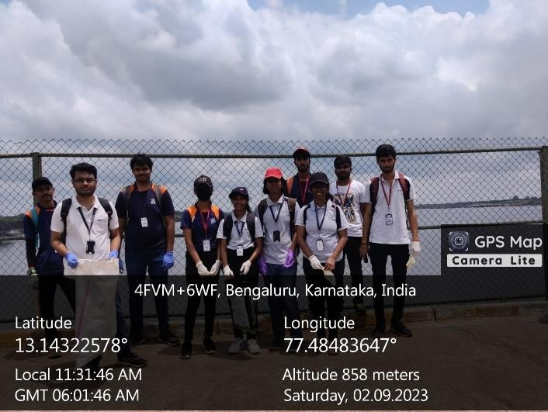

**Figure No - 2.1**

### Background and Significance

The Durgamba Temple is an emblem of spirituality and cultural heritage, nestled on the Hessaraghatta Lake Bund, a serene locale known for its natural beauty. The temple is

dedicated to Goddess Durga and plays a pivotal role in the religious and cultural life of the region. This report aims to provide an in-depth exploration of this sacred site.

The Durgamba Temple is an oasis of spirituality, nestled on the serene bund of Hessaraghatta Lake, approximately 30 kilometers north of Bangalore, India. This temple, dedicated to

Goddess Durga, provides a unique blend of tranquility, history, and devotion in a picturesque setting. In this comprehensive report, we will delve into various aspects of the Durgamba Temple, encompassing its historical roots, cultural significance, architectural features, and the immersive experience it offers to pilgrims and travelers alike.

The Durgamba Temple, located on the Hessaraghatta Lake Bund near Bangalore, India, is not just a physical structure; it's a living testament to the rich tapestry of history, culture, and spirituality that defines the region. Understanding the background and significance of this sacred site is essential to appreciate its enduring importance.

#### Historical Roots:

The historical origins of the Durgamba Temple are not extensively documented, but it is

believed to have been a place of worship for several decades, if not longer. Over time, it has become an integral part of the cultural and spiritual landscape of the region. Its historical

roots are intertwined with the local community's heritage, embodying the collective memory of generations who have sought solace, guidance, and blessings within its sacred precincts.

#### Architectural Elegance:

The temple's architecture stands as a striking fusion of traditional South Indian design and modern artistic elements. It is characterized by a majestic towered gateway (gopuram), intricate carvings, and vivid paintings. The architectural elegance is a testament to the craftsmanship and artistic expression that the temple represents. This synthesis of traditional and contemporary design creates an inviting ambiance that resonates with visitors and

devotees alike.

#### Cultural Significance:

The Durgamba Temple holds profound cultural significance for the local community and beyond. It is dedicated to Goddess Durga, a powerful and revered deity in Hindu mythology. The temple serves as a site for daily rituals, religious practices, and the offering of prayers. During festivals and celebrations, such as Navaratri, its cultural significance shines brightly. These events bring the community together, fostering a sense of unity and reinforcing cultural traditions.

#### Journey to Serenity:

The journey to the Durgamba Temple is a transformative experience. Visitors depart from the bustling city of Bangalore and embark on a peaceful drive to the tranquil Hessaraghatta Lake. The route takes them through scenic landscapes, with lush greenery and winding roads. This journey sets the stage for a meaningful visit, gradually transitioning from the urban hustle to the serene countryside.

### Objectives

To understand the historical origins and cultural importance of the Durgamba Temple. To analyze the architectural elements that make the temple unique.

To explore the spiritual and cultural significance of the temple in the lives of devotees. To examine the journey to the temple, its surroundings, and the overall visitor experience.

To assess the challenges faced by the temple and recommend measures for preservation and conservation.

## Temple Overview

The Durgamba Temple, situated on the picturesque Hessaraghatta Lake Bund, approximately 30 kilometers to the north of Bangalore, India, is a place of profound spirituality and cultural significance. It occupies a serene spot along the banks of Hessaraghatta Lake, a rain-fed reservoir surrounded by lush greenery and rolling hills. This unique location not only

provides a breathtaking backdrop to the temple but also plays a crucial role in its identity.

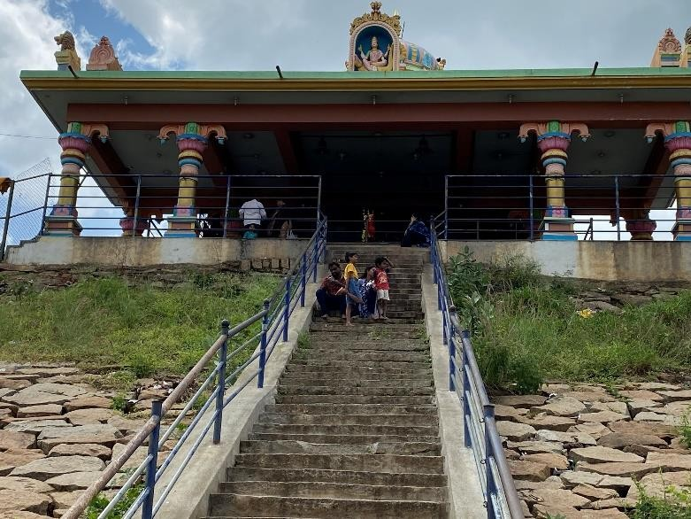

**Figure No – 3.1**

### Location and Setting

The Durgamba Temple is located on the Hessaraghatta Lake Bund, approximately 30 kilometers north of Bangalore. This section provides a detailed overview of its location, the scenic beauty of the surroundings, and the temple's architectural integration with its

environment.

The Durgamba Temple stands majestically on the bund of Hessaraghatta Lake. The temple's location on the bund ensures that it enjoys breathtaking panoramic views of the lake and the lush, rolling hills in the background. The combination of natural beauty and spirituality gives this temple a unique aura of tranquility.

The temple is relatively compact in size, adhering to the traditional South Indian temple

architectural style. Its layout consists of a sanctum sanctorum (garbhagriha) where the idol of Goddess Durga is enshrined, a spacious hall for devotees (mandapa), and a towered gateway

(gopuram) adorned with intricate carvings. The temple's inner sanctum is the most sacred space and the primary site for rituals and offerings.

### Historical Background

While the precise historical origins of the temple are not widely documented, it is believed to have been in existence for several decades, serving as a revered place of worship. This section delves into the historical context of the temple and its cultural evolution over the years.

While exact historical details are limited, the Durgamba Temple is believed to have a long

history dating back many decades or even centuries. It has been a cherished place of worship for generations, passed down through the local community. The temple's history is a testament to the enduring cultural and spiritual importance of this site.

The exact historical origins of the Durgamba Temple are not extensively documented, but it is believed to have stood for several decades, if not centuries. Its historical roots are deeply intertwined with the local community's cultural and spiritual heritage. The temple's historical significance is a testament to its enduring role in the lives of the people who have sought solace and spirituality within its sacred walls.

The temple's architecture, adorned with traditional South Indian design elements and modern touches, reflects a harmonious blend of the old and the new. The temple complex consists of a sanctum sanctorum (garbhagriha), a spacious hall for devotees (mandapa), and a

prominently decorated towered gateway (gopuram) with intricate carvings.

The central deity of the temple is Goddess Durga, a powerful and protective figure in Hindu mythology. The idol, exquisitely adorned with jewelry and traditional clothing, is the focal point of devotion and worship. The temple's intricate carvings, colorful paintings, and floral decorations contribute to its aesthetic beauty.

The Durgamba Temple is a site of daily rituals and religious practices. Devotees gather to offer their prayers, participate in aartis (rituals involving the offering of light), and seek

blessings from the goddess. The temple is especially vibrant during festivals and celebrations, such as Navaratri, where the cultural and spiritual significance of the temple shines brightly.

The temple serves as a cultural center for the local community, hosting traditional music, dance, and art performances during festivals. These events not only celebrate the cultural diversity of the region but also bring communities together, strengthening the bonds of tradition and faith.

The Durgamba Temple visit offers a unique journey from the bustling city of Bangalore to a tranquil countryside setting. The drive to the temple takes visitors along winding roads, surrounded by lush greenery and the refreshing ambiance of Hessaraghatta Lake. Upon

arrival, visitors are greeted by the soothing presence of the lake and the temple's peaceful surroundings.

The temple visit experience is deeply spiritual and meditative. The serene ambiance, the fragrance of incense, and the melodious chants of prayers create an atmosphere of transcendence. Visitors are encouraged to participate in daily aartis, offering their devotion and seeking blessings from the goddess.

The temple's well-maintained grounds offer seating areas for devotees to meditate or simply enjoy the view of the lake. The surrounding gardens contribute to the temple's overall charm, enhancing the sense of serenity and tranquility that envelops the site.

The local community is actively engaged in the temple's activities, participating in rituals, cultural events, and festivals. The temple plays a central role in fostering community bonds, preserving cultural traditions, and promoting a sense of shared heritage.

Despite its cultural and historical significance, the Durgamba Temple faces preservation and conservation challenges. These challenges are not uncommon for historic sites, particularly those located in areas susceptible to environmental factors and urban development.

The temple's proximity to Hessaraghatta Lake exposes it to environmental factors, including weathering, erosion, and water damage. The fluctuating water levels of the lake pose a

potential risk to the temple's structural integrity. Additionally, the temple's aging

infrastructure, including its architectural elements, requires regular maintenance to ensure its longevity.

The temple's limited financial and human resources for maintenance and upkeep can hinder preservation efforts. It is essential to secure funding and support for ongoing maintenance and conservation.

Urban development in the surrounding area may lead to encroachment and alterations to the temple's natural surroundings, potentially affecting its visual and spiritual ambiance.

Maintaining the temple's peaceful and idyllic setting amid urbanization is a significant challenge.

Cultural changes and evolving demographics can also impact the temple's significance. Younger generations may be less connected to the temple's historical and cultural roots, potentially affecting its long-term cultural relevance.

Natural disasters, such as floods and earthquakes, pose a threat to the temple's structural integrity. Developing an emergency response plan is essential to protect the temple during such events.

Preserving the Durgamba Temple on Hessaraghatta Lake Bund requires a concerted effort from various stakeholders. Here are some recommendations for preserving and conserving this historic and culturally significant site:

**Regular Maintenance**: Establish a routine maintenance schedule to address wear and tear, structural damage, and the overall upkeep of the temple. This includes repairing any

structural damage, repainting, and preserving architectural elements.

**Documentation**: Create comprehensive documentation of the temple's architecture, historical significance, and cultural importance. Detailed records and research are crucial for both preservation efforts and educational purposes.

### Idol and Deity

The central deity of the temple is Goddess Durga, who represents the divine feminine energy and is often depicted as a powerful and protective figure. The idol, adorned with jewels and traditional clothing, is a sight to behold. It is the focal point of worship and devotion for countless visitors.

### Cultural Relevance

The Durgamba Temple holds a significant place in the cultural fabric of the region. It is a testament to the enduring faith and devotion of the local community. Festivals and rituals, such as Navaratri (a nine-night festival dedicated to Goddess Durga) and Durga Puja, are celebrated with great fervor and enthusiasm.

The temple serves as a cultural center, where traditional music, dance, and art forms are practiced and showcased during festivals, strengthening the cultural heritage of the community.

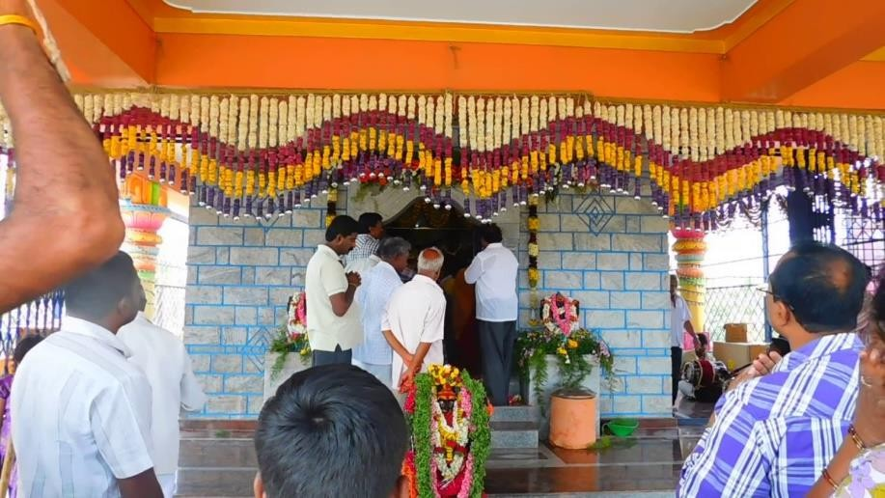

**Figure No – 3.2**

## Architectural Elegance

### Traditional South Indian Architecture

The Durgamba Temple exhibits a blend of traditional South Indian temple design with contemporary elements. This section offers an analysis of the temple's architecture, the significance of the gopuram, and its intricate carvings.

The temple's architecture blends traditional South Indian temple design with modern elements. The gopuram, with its finely detailed sculptures and carvings, is a prominent example of the temple's architectural beauty. The intricate stonework and attention to detail demonstrate the craftsmanship of the artisans who have contributed to the temple's aesthetic appeal.

### Aesthetic Features

The temple's aesthetic beauty is a hallmark of its charm. This part of the report discusses the artistry and decorative elements, such as colorful paintings, sculpted figures, and floral embellishments that make the temple a visual delight.

One of the standout features of the Durgamba Temple is its aesthetic beauty. The colorful

paintings, the sculpted figures, and the floral decorations create a visual feast for visitors. The temple's serene ambiance, set against the backdrop of the lake, makes it an ideal spot for both worship and photography.

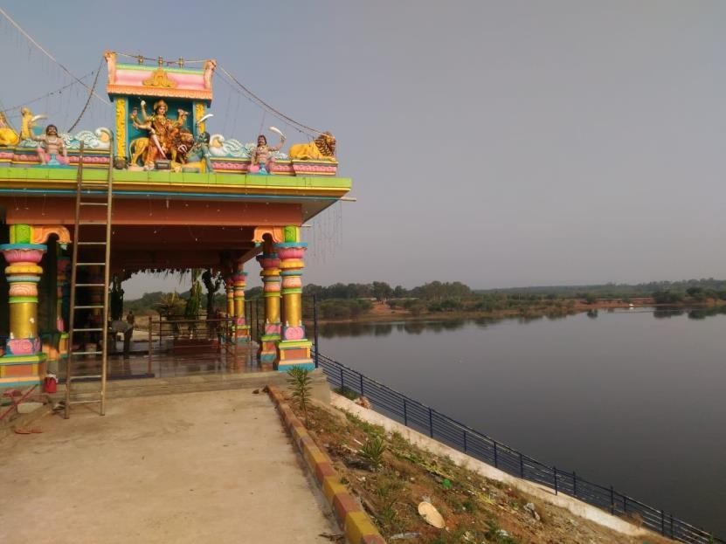

**Figure No - 4.1**

## Cultural Significance

### Religious Traditions

The temple is a hub for religious practices and devotional rituals. This section delves into the religious significance of the temple, the idol of Goddess Durga, and the daily rituals

performed.

### Festivals and Celebrations

Festivals, such as Navaratri, play a significant role in the temple's cultural life. This part of the report discusses the cultural events, traditions, and the vibrant atmosphere during festivals.

## The Journey to Serenity

### Route to the Temple

Visitors journey from Bangalore to reach the Durgamba Temple. This section outlines the travel route, transportation options, and the scenic beauty along the way.

Reaching the Durgamba Temple on the Hessaraghatta Lake bund is a journey that takes you away from the bustling city of Bangalore into the peaceful countryside. The temple is accessible by road and is approximately a 30-kilometer drive from the heart of Bangalore.

The journey itself is an experience, with winding roads, beautiful scenery, and the anticipation of reaching the temple.

### Arrival Experience

The experience of arriving at the temple is a significant part of the visit. This part of the report narrates the initial moments, from parking to the first glimpse of the temple.

Hessaraghatta Lake, a prominent rain-fed reservoir, enhances the appeal of the temple's location. The lake is a vital water source for the region and also a popular spot for nature enthusiasts and birdwatchers. Its tranquil waters, surrounded by greenery, provide a perfect backdrop for the temple.

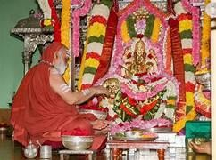

**Figure No - 6.1**

## The Temple Visit Experience

### Spiritual Atmosphere

The temple exudes a spiritual ambiance that deeply affects visitors. This section explores the serene atmosphere, its impact on meditation and introspection, and the soothing sounds of the temple.

Upon entering the temple premises, a sense of serenity immediately envelops visitors. The peaceful atmosphere, the sound of the gentle breeze, and the view of the lake create an ideal setting for reflection and prayer. The temple grounds are well-maintained and feature comfortable seating areas where devotees can sit and soak in the atmosphere.

### Rituals and Devotional Practices

Visitors are encouraged to engage in daily rituals and practices at the temple. This part of the report describes the significance of rituals, the role of the priest, and the devoutness of

devotees.

The temple is known for its daily rituals and aartis. Visitors are encouraged to participate in the ceremonies, which involve the offering of light to the deity. The priests are welcoming and offer insights into the temple's history and significance. The aarti, accompanied by the melodious chants of mantras, creates a spiritually uplifting experience.

### Natural Beauty of Hessaraghatta Lake

Hessaraghatta Lake, with its serene waters and lush greenery, adds to the temple's charm. This section emphasizes the natural beauty and the role of the lake in enhancing the temple visit experience.

The temple's serene ambiance makes it a perfect place for meditation and introspection. Many visitors find solace and inner peace while sitting by the lake or within the temple complex. It's an ideal spot for individuals seeking a break from their hectic routines to reconnect with their inner selves.

## Community and Devotees

### Local Involvement of Devotees and Pilgrims

The Durgamba Temple is an integral part of the local community. This section profiles the community, their involvement in temple activities, and the impact of the temple on their lives.

The Durgamba Temple is frequented by both locals and pilgrims from neighboring areas.

Devotees visit the temple to seek the blessings of Goddess Durga, offer prayers, and participate in cultural events. The temple serves as a center for spiritual and cultural activities, strengthening the bond within the community.

### Cultural Impact

Festivals and cultural events at the temple have a profound impact on the region. This part of the report discusses the cultural significance and how the temple contributes to the local cultural heritage.

The temple comes alive during festivals like Navaratri and Durga Puja. These events draw a large number of visitors, and the temple complex is adorned with vibrant decorations and traditional art forms. The temple is an integral part of these celebrations, highlighting the cultural vibrancy of the region.

## Challenges and Preservation

### Challenges and Preservation

The Durgamba Temple faces challenges related to its preservation and maintenance. This section discusses these challenges and the ongoing efforts to protect and preserve the temple.

While the Durgamba Temple continues to stand as a symbol of faith and spirituality, it faces challenges related to maintenance and preservation. Ensuring the long-term preservation of the temple's historical and cultural significance is of paramount importance. Measures to protect the temple's architectural features and cultural heritage are essential for its continued relevance.

The challenges and preservation efforts related to the Durgamba Temple on Hessaraghatta Lake Bund are crucial to ensure the longevity of this historic and culturally significant site. Let's discuss some of the challenges and potential preservation strategies:

#### Challenges

**Environmental Factors**: The temple's location near Hessaraghatta Lake makes it susceptible to environmental factors, including weathering, erosion, and water damage. The lake's water levels may fluctuate, impacting the temple's structural integrity.

**Aging Infrastructure**: The temple, like many historical structures, faces wear and tear over time. Aging infrastructure, including the temple's architectural elements, carvings, and

paintings, requires regular maintenance.

**Limited Resources**: Many smaller, local temples struggle with limited financial and human resources for maintenance and upkeep. Adequate funding for preservation efforts may be lacking.

**Modern Development**: The surrounding area is subject to urban development. Increased construction and population growth can lead to encroachment and alterations to the natural surroundings, potentially affecting the temple's visual and spiritual ambiance.

**Cultural Changes**: The temple's cultural significance may diminish over time due to changing demographics and values. Younger generations may be less connected to the temple's historical and cultural roots.

**Natural Disasters**: The region is prone to natural disasters, such as floods and earthquakes, which could pose a threat to the temple's structural integrity.

### Recommendations for Preservation

#### Preservation Efforts

**Regular Maintenance**: Establish a regular maintenance schedule to address wear and tear.

This includes repairing structural damage, repainting, and preserving the temple's architectural elements.

**Documentation**: Create detailed documentation of the temple's architecture, historical significance, and cultural importance. This will help in both preservation efforts and education.

**Community Involvement**: Encourage the local community's active participation in the temple's preservation. Their emotional and cultural connection to the temple is invaluable.

**Funding and Grants**: Seek financial assistance from government agencies, cultural preservation organizations, and philanthropic donors. Apply for grants and funding programs dedicated to the conservation of historical and cultural sites.

**Conservation Specialists**: Collaborate with conservation experts and heritage organizations to assess the temple's structural stability and guide preservation efforts.

**Educational Initiatives**: Promote awareness and educate the local community, visitors, and tourists about the temple's historical and cultural significance. This can foster a sense of responsibility for its preservation.

**Adaptive Reuse**: Consider adaptive reuse of adjacent land for the temple's economic sustainability. This could generate funds for maintenance while preserving the temple's sanctity.

**Sustainable Practices**: Implement sustainable practices in and around the temple to minimize environmental impact. This includes eco-friendly landscaping and waste management.

**Emergency Preparedness**: Develop an emergency response plan to protect the temple during natural disasters. This plan should outline steps for evacuation and structural reinforcement.

**Collaborative Efforts**: Collaborate with academic institutions and heritage organizations to conduct research, document findings, and develop preservation strategies.

The Durgamba Temple on Hessaraghatta Lake Bund stands as a cultural and historical treasure, and preserving it requires the collective effort of the local community, heritage enthusiasts, and authorities. By addressing the challenges and implementing effective preservation strategies, we can ensure that this sacred site continues to be a source of inspiration and cultural significance for generations to come.

## Conclusion

### Significance of Durgamba Temple

The Durgamba Temple, situated on the Hessaraghatta Lake Bund, is not merely a physical structure; it is a testament to the enduring power of spirituality, history, and culture. A visit to this sacred site offers a unique blend of tranquility, architectural elegance, and a connection to traditions that have withstood the test of time.

The temple's historical roots, though not extensively documented, speak to its long-standing presence in the hearts of the local community. It is a place where the echoes of devotion and cultural significance resonate through the ages. The temple's architectural beauty, showcasing traditional South Indian design with a touch of modernity, stands as a testament to the craftsmanship and artistic expression that our cultural heritage cherishes.

Culturally, the Durgamba Temple plays a pivotal role in the lives of the local community. It is a hub of religious practices, a site of devotional rituals, and a venue for vibrant celebrations during festivals like Navaratri. The temple's impact reaches far beyond its walls, as it

strengthens the local cultural heritage and connects generations.

### Personal Reflection

The journey to the temple is an experience in itself. The tranquil drive from Bangalore to the serene surroundings of Hessaraghatta Lake prepares visitors for the spiritual and cultural

immersion that awaits them. The arrival experience, from the anticipation of the visit to the first glimpse of the temple, sets the tone for a transformative experience.

Once inside the temple, visitors are enveloped in a spiritual ambiance that encourages introspection and meditation. The daily rituals and devotional practices, led by the priest and accompanied by melodious chants, create an atmosphere of deep spirituality. The natural beauty of Hessaraghatta Lake, with its calm waters and verdant surroundings, adds to the temple's allure.

The local community's involvement in the temple is palpable. Their devotion and active participation in cultural events and rituals are at the heart of the temple's existence. The temple's significance in the cultural landscape of the region cannot be overstated.

However, this revered site is not without its challenges. Maintenance and conservation efforts are essential to ensure that the Durgamba Temple continues to inspire future generations.

Recommendations for preservation include measures to safeguard the temple's cultural and historical heritage, as well as increased community involvement.

In conclusion, the Durgamba Temple on the Hessaraghatta Lake Bund is a place where spirituality, culture, and history harmoniously converge. It offers visitors a unique opportunity to connect with traditions that have been cherished for generations, while also providing a tranquil escape from the bustle of everyday life. The temple stands as a testament to the enduring significance of places of worship, and it continues to hold a special place in the hearts of those who seek solace, spirituality, and a deeper connection to their cultural

roots. As we conclude our exploration, we are left with a profound appreciation for the enduring legacy of the Durgamba Temple and a sense of reverence for the cultural treasures it represents.

### References

#### Links: -

1. <https://www.touristlink.com/india/hesaraghatta-lake/overview.html>
2. [https://www.ishtadevata.com/temple/durgamba-devastana-antharagatte-](https://www.ishtadevata.com/temple/durgamba-devastana-antharagatte-chikmagalur/) [chikmagalur/](https://www.ishtadevata.com/temple/durgamba-devastana-antharagatte-chikmagalur/)
3. <https://en.wikipedia.org/wiki/Hesaraghatta_Lake>